caAdapter Mapping and Persistence Service (CMPS)

Software Design Description
Version 1.0

August 20, 2008

DOCUMENT REVISION HISTORY
Version Number | Date | Description
1.0 | 20-AUG-08 | - Initial Draft

Table of Content
1 Introduction 5
1.1 Background/Summary 5
1.2 Overview 5
1.3 Using XQuery as the mapping engine technology 5
2 CMPS Core Technology 6
2.1 CMPS Requirement Analysis 6
2.2 Matching XQuery with CMPS requirements 8
2.2.1 XQuery features 8
2.2.2 Matching with CMPS requirement 9
3 Software Architecture 11
3.1 Core Data Models 11
3.2 Core Engines 12
3.3 Persistence Controller 13
3.4 Input and Output adapters 13
3.5 Interfaces 14
4 Data Model Detailed Design 15
4.1 Core Meta Data Model 15
4.2 Functions Meta 16
4.3 Core Components Model 17
4.4 Core Mapping Model 18
5 Mapping rules and processing logic 19
5.1 Mapping Components 19
5.2 Mapping rules 20
5.2.1 Matching components 20
5.2.2 Hierarchical relationship 20
5.2.3 All mapping need to be explicit 20
5.3 Basic Mapping Processing 20
5.3.1 Simple Element and Attribute Mapping 20
5.3.2 Parent child chain mapping 22
5.3.3 Parent-Child chain inverted mapping 23
5.3.4 Mapping with Joined Elemenets 25
6 Performance Considerations 28
7 Appendix A - References 29
8 Appendix B - XQuery compared with other technology 30
1. Origin 30
2. Usability 30
3. Data type 30
4. Efficiency 31
5. Future Trend 31
6. The weakness of XQuery: 31
9 Appendix D - Open Source Implementation to be used 32
9.1 XQuery Java implementation 32
9.2 XQuery Supporting packages 32
10 Appendix E - Table of Figures 34

Introduction

Background/Summary
This document contains the Design Description for the caAdapter Mapping and Persistence Service (CMPS) Mapping Engine. The CMPS module provides the following capabilities:
- Perform data elements mapping between a different data structures. Source and target data structures will include: CSV, XML, Relational Database Structure, HL7 v2, HL7 v3, and an application’s APIs as a target
- Perform data transformation once the mapping is completed
- Support data persistence functions into a target data store

Overview
The caAdapter Mapping and Persistence Service (CMPS) Module is a new sub-project of caAdapter. It will extend caAdapter’s data mapping and transformation capabilities to support more generic data formats, more advanced mapping functionality, and new data persistence functions. The CMPS module will assist with persisting the data into a target data store. It will employ the principals of the Service Oriented Architecture (SOA) for clinical data exchange. Implementing SOA using web services, Windows application, or other methods, promotes leveraging clinical research data residing in existing applications and make it available to others.
The main purpose of CMPS Module is to facilitate data exchange between existing applications. The goal is to translate data in various formats and syntaxes without touching the target applications. The mapping engine is the core element of the CMPS Module architecture. And for the various formats and syntaxes we wanted to support, XML with schema is the most generic and flexible format. So XML mapping technology is the key decision point of the CMPS mapping engine.

Using XQuery as the mapping engine technology
XQuery is a query language (with some programming language features) that is designed to query collections of XML data. It is semantically similar to SQL.
XQuery is standardized by W3C, the organization that maintains all XML related standards such as XML, XML Schema, SOAP, and WSDL. It also gains support from major software vendors such as Microsoft, IBM, Oracle, and SUN Microsystems from the very beginning of its standardization process.
XQuery provides the means to extract and manipulate data from XML documents or any data source that can be viewed as XML, such as relational databases or office documents.
XQuery is a programming language that can express arbitrary XML to XML data transformations with the following features:
- Logical/physical data independence
- Declarative
- High level
- Side-effect free
- Strongly typed language
This document will recommend XQuery as the best technology available for CMPS module, and provide justification by comparing it with our requirement and other technologies.
We analyzed XQuery technology, including the current XQuery 1.0 standard released in 2006, and the recent developments, such as XQuery Update facility, and XQuery 1.1 requirements. We also compared XQuery with other technologies, such as XSLT. We decided that XQuery is the most suitable technology for our application.

CMPS Core Technology

CMPS Requirement Analysis
The main objective for the CMPS module is to be able to map a source to a target data structure, transform the data, and perform persistence when applicable. Table 1 below lists all possible source and target data structures and determined the mapping requirements between each pair.
Table 1 – Valid Source-to-Target Data Structures Mapping, Conversion, and Persistence when applicable
Target Data Structures ➔ | CSV | XML | RDBMS | API | Mapping from Multiple Sources Allowed?
Source Data Structures
⬇
CSV | ✓ | ✓ | ✓ | ✓ | YES
XML | ✓ | ✓ | ✓ | ✓ | YES
HL7 v2 | ✓ | ✓ | ✗ | ✓ | NO
HL7 v3 | ✓ | ✓ | ✗ | ✓ | NO

Table 2 – Master List of Data Structures and Metadata Formats
Data Structure | Source / Target | Metadata Format
CSV | Source & Target | XML file (SCS schema file, in XML format)
XML | Source & Target | XML schema file (XSD)
Relational Database | Target Only | - XML file  - DDL file
HL7 v2 | Source Only | - HL7 v2 schema (XSD)
HL7 v3 | Source Only | - HL7 v3 specifications file
A System’s Write APIs | Target Only | - WSDL file  - XSD file
From Table 1 and Table 2 we can see that at the core of the CMPS mapping is to deal with XML data. The majority of metadata formats are in XML, and the rest of them can be easily convert to XML. Also in the mapping scenarios, mapping to and from XML can be seen as the most generic and complex use case.
The mapping of XML data involves:
- Ability to query the source data by tag, attributes, and other criteria.
- Ability to assemble the result into XML structure that fits the target data format.
- Ability to combine data from multiple source into a single target, i.e., similar to the join functions in relational databases.
- Ability to process other logics and functions when deriving the target data from the source data.
- Ability to process data types, which is a new feature of XML and defined by XML Schema.
- Effectively process all kinds of XML data, which in our cases, originates from various data source, such as CSV and Relational Database.

Matching XQuery with CMPS requirements
XQuery as stated in the W3C mission statement:
"The mission of the XML Query project is to provide flexible query facilities to extract data from real and virtual documents on the World Wide Web, therefore finally providing the needed interaction between the Web world and the database world. Ultimately, collections of XML files will be accessed like databases".
So since the very beginning, it is designed to support query and extract data from XML, and has flexibility and efficiency in mind.

XQuery features
XQuery provides the means to extract and manipulate data from XML documents or any data source that can be viewed as XML, such as relational databases or office documents.
XQuery uses XPath expression syntax to address specific parts of an XML document. It supplements this with a SQL-like "FLWOR expression" for performing joins. A FLWOR expression is constructed from the five clauses after which it is named: FOR, LET, WHERE, ORDER BY, RETURN.
The language also provides syntax allowing new XML documents to be constructed. Where the element and attribute names are known in advance, an XML-like syntax can be used; in other cases, expressions referred to as dynamic node constructors are available. All these constructs are defined as expressions within the language, and can be arbitrarily nested.
The language is based on a tree-structured model of the information content of an XML document, containing seven kinds of node: document nodes, elements, attributes, text nodes, comments, processing instructions, and namespaces.
The type system of the language models all values as sequences (a singleton value is considered to be a sequence of length one). The items in a sequence can either be nodes or atomic values. Atomic values may be integers, strings, booleans, and so on: the full list of types is based on the primitive types defined in XML Schema.

Matching with CMPS requirement
Matching XQuery with CMPS requirements for XML mapping, we get the following table.

Table 3 – Match XQuery features against CMPS requirement
CMPS Mapping requiirement | XQuery feature
Ability to query the source data by tag, attributes, and other criteria. | uses XPath expression syntax to address specific parts of an XML document
Ability to assemble the result into XML structure that fits the target data format. | Provides syntax allowing new XML documents to be constructed. Both static and dynamic node constructions are supported
Ability to combine data from multiple source into a single target, i.e., similar to the join functions in relational databases. | Supports a SQL-like "FLWOR expression" for performing joins.
Ability to process other logics and functions when deriving the target data from the source data. | Supports all XPath available functions, and with possible expansion in the future.
Ability to process data types, which is a new feature of XML and defined by XML Schema. | The language has a type system that builds on top of primitive types defined in XML Schema.
Effectively process all kinds of XML data, which in our cases, originates from various data source, such as CSV and Relational Database. | Support all standard information content of an XML document, containing seven kinds of node: document nodes, elements, attributes, text nodes, comments, processing instructions, and namespaces.

Software Architecture
The objective of CMPS architecture design is to leverage the state-of-art Java and XML technologies, and to organize in a highly modularized fashion that enables easy expansion that can adapt to any future needs. The architecture should also effectively streamline the main functional modules, so that it can achieve an overall high performance.
The architecture diagram is as following.

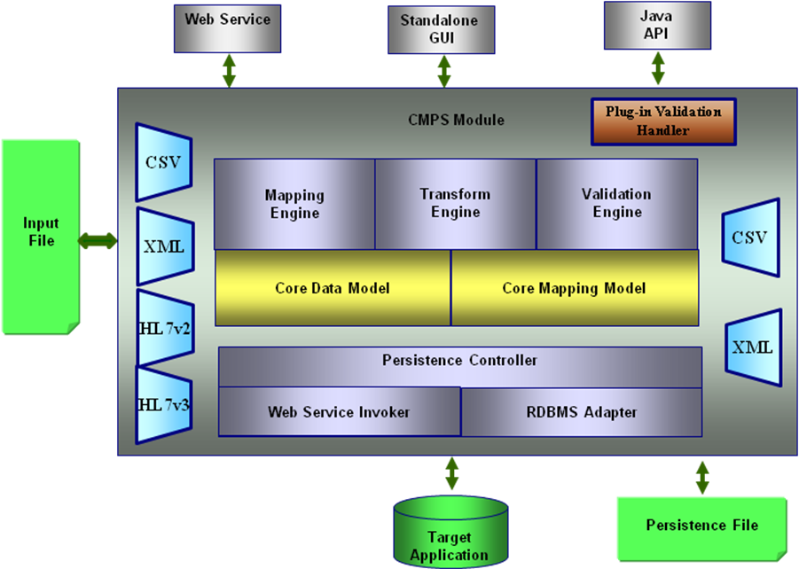
Figure 1 CMPS Architecture Diagram

Core Data Models
At the core of CMPS are the following two data models:
Core Data Model
The unified data model for representing the various data formats.
Core Mapping Model
The unified data model of representing the various mapping relationship and functions based on the Core Data Model.
The CMPS architecture is based on the Core Data Model and the Core Mapping Model, which are unified data model for representing the data and mapping relationship handled by CMPS. By having such a design, the CMPS core mapping engine is much simplified. It can focus on dealing with the mapping relationship and functions. Compared with mapping engine that needs to deal with various data formats and data models directly, which will result in NxN combinations of input and output data models, (where N is the possibilities of data models), such a design is also much more efficient and scalable.
Such design also makes the whole architecture highly modularized. The core modules only deal with the core functionalities, i.e., mapping, transformation, and validation. The other modules handle the various data formats and data models, including input and output. So it is very simple to add capabilities of supporting new data formats into CMPS. It is also very simple to replace any of the modules with better implementation, including replacing the core mapping engine.

Core Engines
Mapping Engine
The Mapping Engine handles the core task of CMPS that creates and manages the mapping relationship that associates source and target data.
Transformation Engine
The Transformation Engine takes the source data and mapping data as input and produce target data as output. By creating XQuery statements from the mapping data, it leverages the XQuery technology to perform the action transformation.
Validation Engine
The Validation Engine handles the validation of source data, mapping data, and target data. It mainly leverages the XML Schema technology to perform the validation.
Plug-in Validation Handler
The Plug-in Validation Handler provides and hook into the Validation Engine to utilize customized validation.

Persistence Controller
Persistence Controller
The Persistence Controller handles the data persistence functionalities of CMPS. It is designed as a protocol independent managing component that takes the target data, i.e., the output of the transformation, and then delegate to the protocol-specific adapters to perform the actual persistence operation. For now, there are two kinds of protocol supported by CMPS.
Web Service Invoker
The Web Service Invoker is a CMPS persistence adapter that handles web service invocation based persistence. It take XML data and web service configurations as input, and make web service calls based on standard SOAP protocol.
RDBMS Adapter
The RDBMS Adapter is a CMPS persistence adapter that handles RDBMS based persistence. It takes XML data as input and creates SQL scripts that can be used to store data to the database.

Input and Output adapters
CSV Adapter
The CSV Adapter handles the input and output of CSV format data. The CSV data are generally treated as segmented CSV that use segmented CSV schema as metadata. The CSV adapter can translate CSV data to XML format based on the segmented CSV schema (scs). It can also produce segmented CSV from XML data for output purpose.
XML Adapter
The XML Adapter handles the input and output XML data. The XML data are generally governed by XML schema (xsd). The XML Adapter parses the input XML and translates into the core data model. It also generates XML from the core data model at output side.
HL7v2 Adapter
The HL7v2 Adapter handles the HL7v2 input data. It parses the input data based on HL7v2 specification and converts into XML data. The XML data can be used as source data of the mapping.
HL7v3 Adapter
The HL7v3 Adapter handles the HL7v3 input data. It parses the input data based on HL7v3 MIF specification and converts into XML data. The XML data can be used as source data of the mapping.

Interfaces
Web service
The Web service interface provides web service interface to invoke transformation functionalities of CMPS.
Standalone GUI
The Standalone GUI provides a Java Swing based GUI interface for user to create and manage mappings and perform transformation and validations. It utilizes drag-and-drop technology to provides a convenient user interface to perform such tasks.
Java API
The Java API provides a Java based interface for user to perform transformation and validations. It can be used to integrate CMPS seamlessly into other applications.

Data Model Detailed Design

Core Meta Data Model
The Core Meta Data Model class diagram is as following.
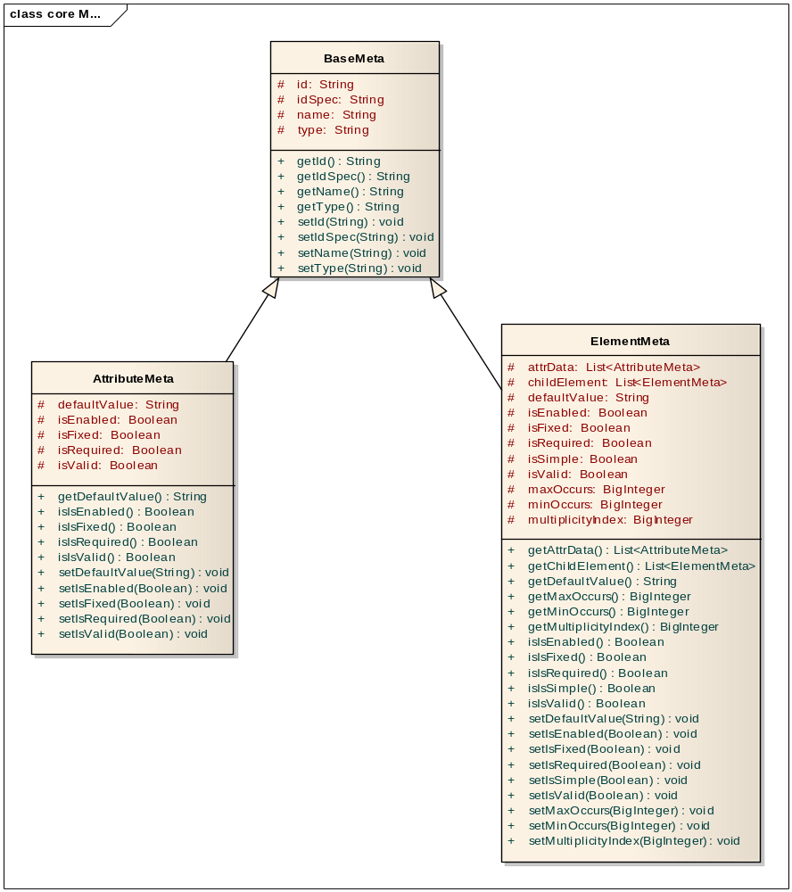
Figure 2 CMPS Meta Data Model

Functions Meta
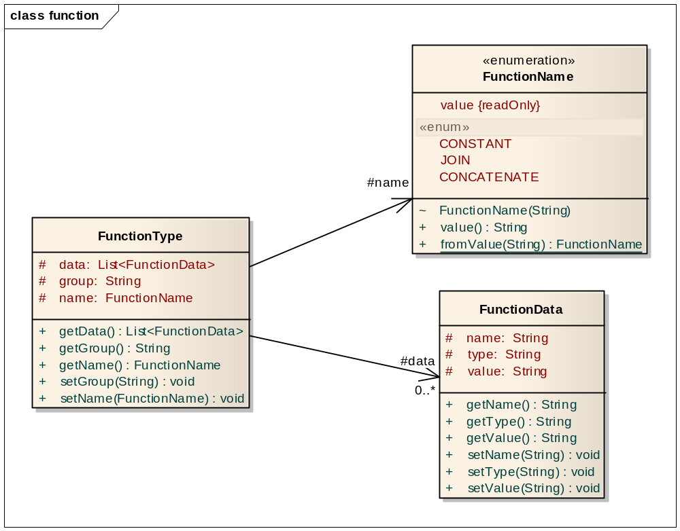
Figure 3 CMPS Functions Meta

Core Components Model
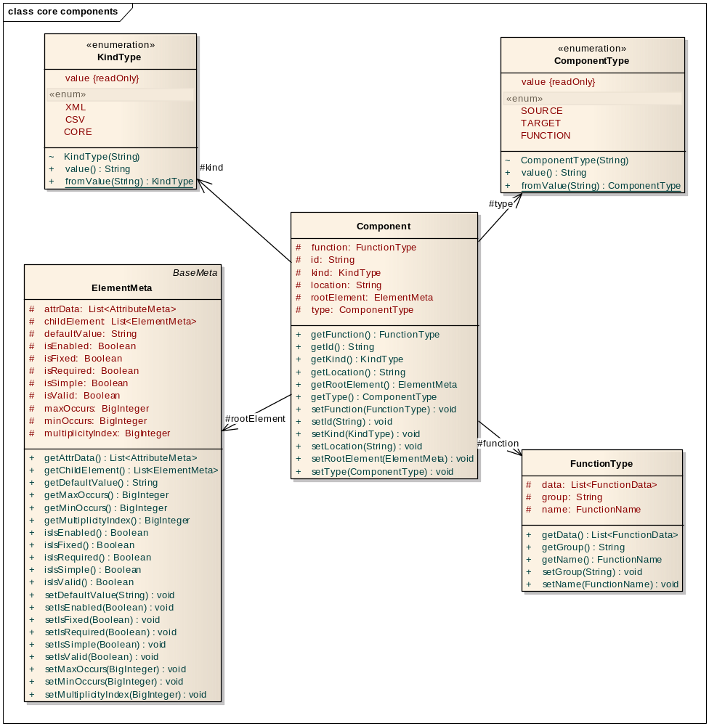
Figure 4 CMPS Components Model

Core Mapping Model

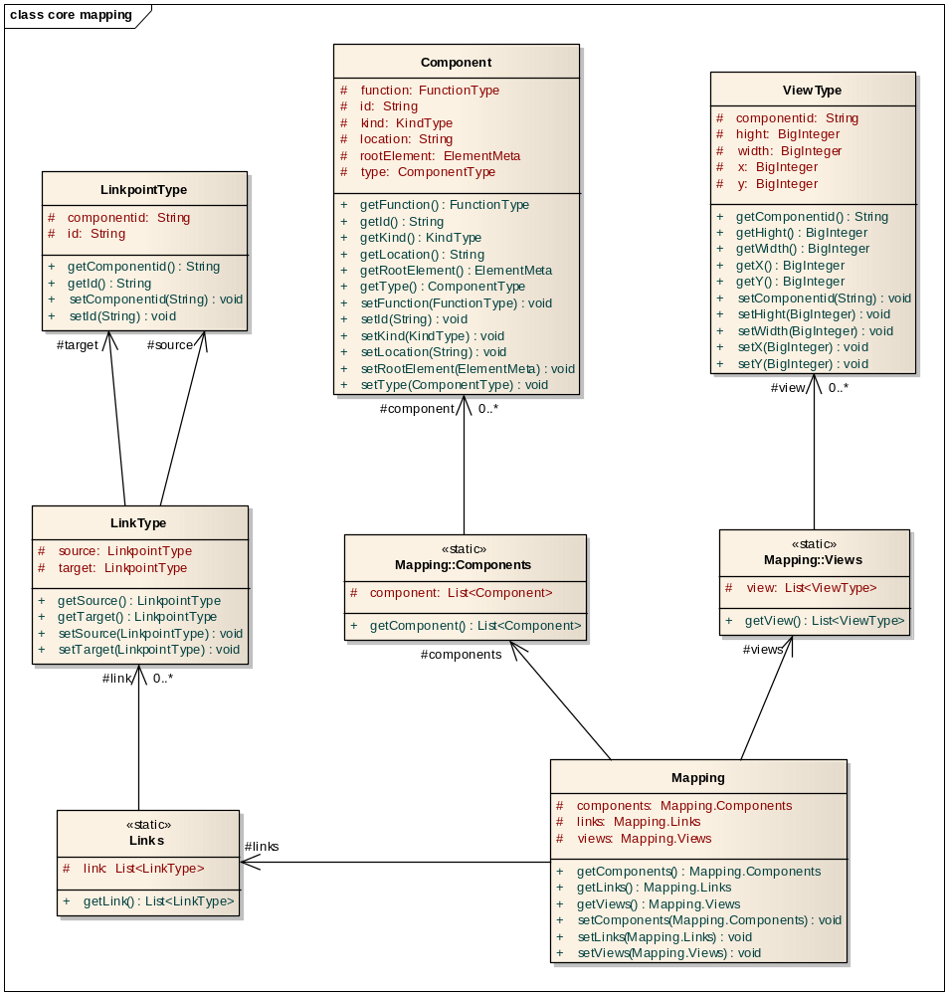
Figure 5 CMPS Mapping Model

Mapping rules and processing logic

Mapping Components
Based on the Core Data Model, we have the following mapping components.
Element
Element corresponds to XML element in XML document, or table in RDBMS, or segment in CSV. It can have parent and children. It can also have attributes attached to it. The whole data model can be represented in GUI as a tree, and the elements appear as nodes in the tree. The number of certain type of children elements under a parent is also called cardinality.
Attribute
Attributes are always attached to elements. An attribute always has a name. Attributes always appear as leaf nodes in the tree representation.
The inline text of an XML element is also viewed as a special attribute of the element.
Link
A link is the basic component of mapping relationships. A link has source and target. The source and target can be data, such as elements and attributes, or functions, such as Join, filter, or other functions.
Generic Function
Generic Function is generalized form of functions. Generic Function is used to represent certain type of operation in the mapping.
Join
Join is one type of Generic Function that performs join relationship that associates multiple source data and produce a list of values.
Filter
Filter is one type of Generic Function that performs filtering operation on source data based on certain criteria and produce a list of values.
Function
Other function includes the normal mathematical functions, logical function and others.

Mapping rules
To be able to formalize the mapping relationships and produce precise transformation rules, the CMPS mapping follows certain rules.

Matching components
A source attribute component can only be mapped to a target attribute component.
An attribute can link to a function, and the output is still of attribute component type.
A source element can only be mapped to a target element.
Join and filter function operates on element components and produce element components.

Hierarchical relationship
A source attribute can only be mapped to a target attribute if the enclosing source element or its ancestor maps to the enclosing target element or its ancestor.

All mapping need to be explicit
All mapping need to be explicitly specified, no implicit mapping will be allowed. This is to avoid any ambiguity.

Basic Mapping Processing
Here we use the segmented CSV as a simple example of source and target data format, and discuss the various mapping scenarios.

Simple Element and Attribute Mapping
This is the simplest mapping scenario. An element from the source data is mapped to an element at the target, and the attributes of the source element are mapped to the corresponding target element.
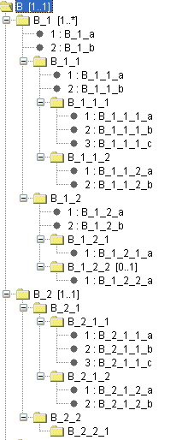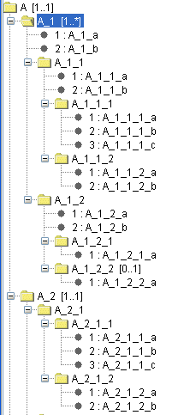
Element Mapping

Attribute Mapping
Figure 6 Simple Element and Attribute Mapping

XQuery:

<B>
<B_1>
For $x in //A/A_1/A_1_1
Return <B_1_1 B_1_1_a={$x/@A_1_1_a} B_1_1_b={$x/@A_1_1_b} />
</B_1>
</B>

Parent child chain mapping
This is the most common mapping scenario. A chain of parents and children in source data are mapped to a chain of elements at the target, with attributes at different levels of source elements mapping to the corresponding levels of target elements.
Element Mapping

Attribute Mapping
Figure 7 Parent-child chain mapping

XQuery:

<B>
<B_1>
For $x in //A/A_1/A_1_1
Return{
<B_1_1 B_1_1_a={$x/@A_1_1_a} >
For $y in $x/A_1_1_1
Return{
<B_1_1_2 B_1_1_2_a={$y/@A_1_1_b} />
}
</B_1_1>
}

</B_1>
</B>

Parent-Child chain inverted mapping
This is a special mapping scenario that contrary to the previous mapping scenario. A chain of parents and children in source data are mapped to a chain of elements at the target, with attributes at different levels of source elements mapping to the corresponding levels of target elements. But the parent and child relationship is inverted.

Element Mapping

Attribute Mapping
Figure 8 Parent-child chain inverted mapping

XQuery:

<B>
<B_1>
For $x in //A/A_1/A_1_1/A_1_1_1
Return{
<B_1_1 B_1_1_a={$x/@A_1_1_1_b} >
For $y in $x/..
Return{
<B_1_1_2 B_1_1_2_a={$y/@A_1_a} />
}
</B_1_1>
}

</B_1>
</B>

Mapping with Joined Elemenets
This is a mapping scenario that involves Join operations. Two elements in source data are Joined by certain conditions and then mapped to one target element. The attributes of the target element are derived from the attribute sets of the source elements.

Element Mapping

Attribute Mapping
Join: A_1_1_a = A_1_2_a
Figure 9 Mapping with Joined Elements

XQuery:

<B>
<B_1>
For $x in //A/A_1/A_1_1, $y in //A/A_1/A_1_2
Where $x/@A_1_1_a = $y/@A_1_2_a
Return{
<B_1_1 B_1_1_a={$x/@A_1_1_b} B_1_1_b={$x/@A_1_2_b} />
}

</B_1>
</B>

Performance Considerations

Appendix A - References
- caAdapter CMPS Module Scope Document
- caAdapter CMPS Use Case Document
- caAdapter CMPS Software Requirement Document
- W3C XML Query (XQuery), http://www.w3.org/XML/Query
- XQuery Update facility working draft, http://www.w3.org/TR/xqupdate/
- JSR 255 XQuery API for Java (XQJ)
- XQuery 1.1 requirements, http://www.w3.org/TR/xquery-11-requirements
- XQuery and XPath Full Text 1.0
- XQuery Scripting Extension 1.0 Requirements
- XQuery from the Experts: A Guide to the W3C XML Query Language, By Howard Katz, Don Chamberlin, Denise Draper, Mary Fernandez, Michael Kay, Jonathan Robie, Michael Rys, Jerome Simeon, Jim Tivy, Philip Wadler, Published Aug 22, 2003 by Addison-Wesley Professional.

Appendix B - XQuery compared with other technology
There are also other technologies available to perform query on XML data. Mainly they are XPath and XSLT.
XPath is the common basis of XQuery and XSLT, so all its functionalities are subset of those of XQuery or XSLT. So XSLT appears as the main alternative to XQuery.
Comparing to XQuery, XSLT has the following drawbacks:

Origin
XSLT, as its name “Extensible Stylesheet Language Transformations” implies, was primarily conceived as a stylesheet language whose primary goal was to render XML for the human reader on screen, rather than querying and computations.
XSLT is stronger in its handling of narrative documents with more flexible structure, while XQuery is stronger in its data handling, for example when performing relational joins.
XSLT, by its purpose, mainly process single source XML document. While XQuery, was initially conceived as a query language for large collections of XML documents.

Usability
As a language, XQuery is much easier to use than XSLT.
- XQuery is more concise and more like other modern programming languages.
- XSLT is based on XML stylesheet format, and not follows the procedure model of other programming languages.
- XQuery is more orthogonal, in that any expression can be used in any syntactic context.
- XSLT is a two-language system in which XPath expressions can be nested in XSLT instructions but not vice versa.

Data type
XQuery has data type build-in and XML schema aware.
XSLT 1.0 does not have data type and treat data as the general XML strings. It is also not schema aware.
XSLT 2.0 is heavily influenced by XQuery and has strong typing and schema-awareness.

Efficiency
XQuery is designed for database type of application, so it is carefully designed for optimization. It can be expected that XQuery will in general deliver better performance than XSLT.

Future Trend
XQuery 1.0 is still in very early stage, and more features are already planned for version 1.1, such as grouping, full text search, in place update, script extension, etc. All will be very useful in data mapping.

The weakness of XQuery:
XQuery is a very new technology, and only has version 1.0 releases in 2006. So the weakness is its current feature set as a whole is not as powerful as XSLT. Also the implementation are not so mature and widely available as XSLT.
XSLT 1.0 is released in 1999 and widely used and implemented. But XSLT lacks the key data typing features as XQuery and XSLT 2.0 have. But XSLT 2.0 is defined and released at nearly the same time as XQuery 1.0, so it also lacks support as XQuery.

Appendix D - Open Source Implementation to be used

XQuery Java implementation
The leading open source Java implementation of XQuery is Saxon. Saxon implements the latest W3C standard for XPath 2.0, XSLT 2.0, and XQuery 1.0. It also supports the latest XQJ standard from Sun Java community.
But Saxon is released in two versions: Saxon-B, which is open source, and Saxon-SA, which is commercial.
Saxon-B compared with Saxon-SA, lacks the following features:
- XML Schema 1.0 Support
- Advanced Extension Functions
- Advanced Optimizer
- Streaming
- Java Code Generation
Other open source java implementation of XQuery are:
XQEngine: http://xqengine.sourceforge.net/
XQEngine is now still in development stage, and only have partial support of XQuery 1.0 standard. So it is currently not usable for our product. But we can keep track of its progress.
Currently, we recommend Saxon, the leading open source implementation of XQuery as our choice of XQuery engine. But if we follow the standard interface of XQuery, we should be able to easily replace the engine if we find better choice in the future.

XQuery Supporting packages
Xerces is the underlying XML parser used by Saxon. It is the de facto standard of open source Java XML parser, and is being used as underlying parser of almost all open source XML projects.
For using Saxon, we also recommend to use Nux, which is another open source project that provides useful wrapper around Saxon API. Though it is not necessary, it could save some developing time to integrate Saxon XQuery functionalities.

Appendix E - Table of Figures

Figure 1 CMPS Architecture Diagram 11
Figure 2 CMPS Meta Data Model 15
Figure 3 CMPS Functions Meta 16
Figure 4 CMPS Components Model 17
Figure 5 CMPS Mapping Model 18
Figure 6 Simple Element and Attribute Mapping 21
Figure 7 Parent-child chain mapping 22
Figure 8 Parent-child chain inverted mapping 24
Figure 9 Mapping with Joined Elements 26

